**Problem Name:** Rotating Tree

**Topic:** Trees

**Tags:** Trees, Array

**Language used:** C++

**Difficulty:** Hard

**Problem Statement:**

You are given a binary tree with N nodes and N-1 edges rooted at node 1, but this tree has a unique property of cyclically rotating its nodes at every level after each second. For example if nodes at level 3 are [4, 5, 6, 7] then after 1 second they will be [7, 4, 5,6]. You need to find the sum of middle elements of all the levels of the tree after K seconds. If there are X nodes at some level then the middle node would be ((X/2)+1)th node.

Initially the nodes at each level are in ascending order of node value.

Note: Here floor division is used for finding the middle element.

**Input Format:**

The first line of input contains N denoting the number of nodes.

Next N-1 lines contain two integers u, v denoting an edge between nodes u and v.

Next line contains an integer K, denoting the seconds.

**Output Format:**

Output the sum of middle elements of all the levels of the tree after K seconds.

**Constraints:**

1 <= N <=1000

1<= u, v <= N

1 <= K <= 107

**Sample Input 1:**

7

1 2

1 3

2 4

2 5

3 6

3 7

2

**Sample Output 1:**

8

**Explanation of Sample Input 1:**

Initially the tree would look like this,

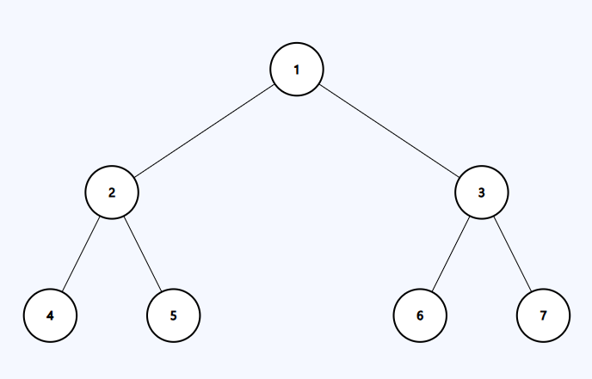

After 1 second, tree would be like,

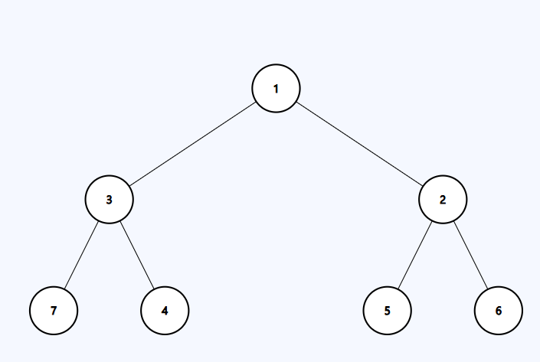

After 2 seconds, tree would be like,

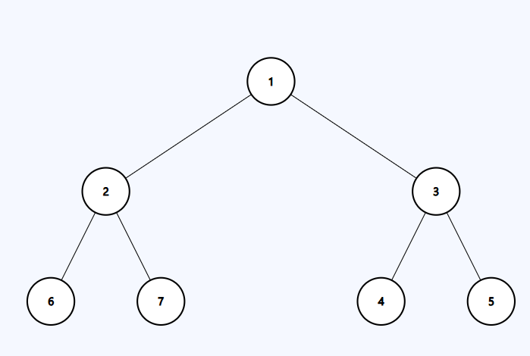

Now the middle element at level 0 is 1.

Middle element at level 1 is 3, as there are 2 nodes at level 1 and the middle node would be ((2/2)+1)th node, which would be the second node of level 1.

Middle element at level 2 is 4, as there are 4 nodes at level 2 and the middle node would be ((4/2)+1)th node, which would be the third node of level 2.

Thus, sum = 1 + 3 + 4 = 8.

**Sample Input 2:**

3

1 3

1 2

1

**Sample Output 2:**

3

**Explanation of Sample Input 1:**

Initially the tree would look like this,

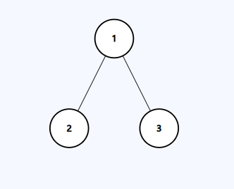

After 1 second, it would be like,

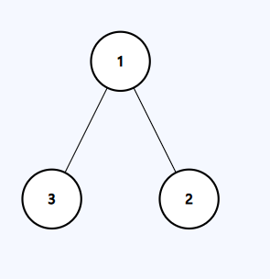

Now the sum of middle elements is 1 + 2 =3.

**Code:**

#include <bits/stdc++.h>

using namespace std;

long int calculate(vector<long int>& temp, long int K){

    sort(temp.begin(),temp.end());

    int middle= temp.size()/2 + 1;

    int size = temp.size();

    K%=size;

    int index;

    if (K >= middle)

      index = (size - K) + (middle - 1);

    else

      index = (middle - K - 1);

    return temp[index];

}

int main()

{

    long int n,u,v,ans=0,i,K;

    cin>>n;

    vector<long int>adj[n+1];

    for(i=0;i<n-1;i++){

        cin>>u>>v;

        adj[u].push_back(v);

    }

    cin>>K;

    queue<vector<long int>>q;

    q.push({1, 0});

    int cur=0;

    vector<long int>temp;

    while(!q.empty()){

        long int node = q.front()[0];

        long int level = q.front()[1];

        q.pop();

        if(level==cur)temp.push_back(node);

        else{

            ans+= calculate(temp, K);

            temp.clear();

            cur=level;

            temp.push_back(node);

        }

        for(auto it:adj[node]){

            q.push({it, level+1});

        }

    }

    ans+= calculate(temp, K);

    cout<<ans<<endl;

    return 0;

}

[C++](https://onecompiler.com/cpp/42jxv3uek)

[Python](https://onecompiler.com/python/42jxv8kua)

[Java](https://onecompiler.com/java/42jxvabyk)